Source ID – 77302099

Source Title -Beijing Linye Daxue Xuebao/Journal of Beijing Forestry University

URL -http://j.bjfu.edu.cn/indexen.htm

1. Go to the URL and select the current issue.

**NOTE: Both chinese and English TOC should be captured.**

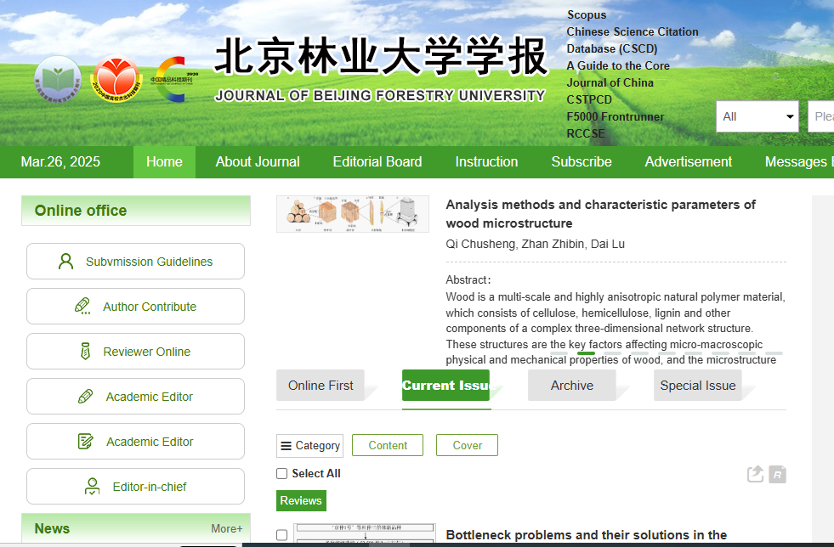

Current issue

2. Capture the meta data shown below.

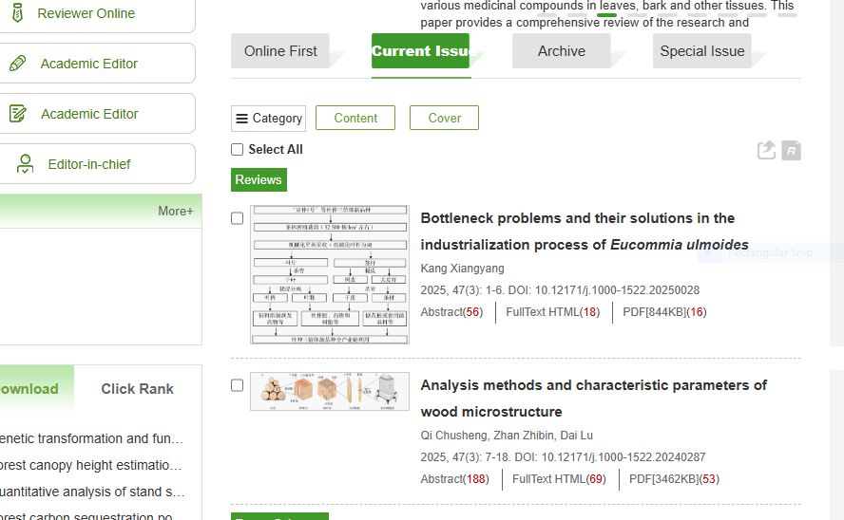

PDF

Page Range

Issue

Volume

Year

DOI

Article title

3. Month is available on the PDF. It should be captured.

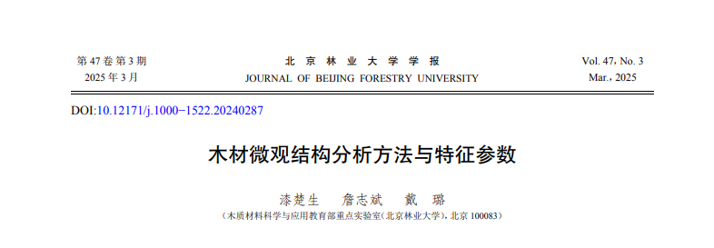

Month

**NOTE: Issue is Available as Mar but should be captured as March.**